Orderbook imbalance overview

According to previous results, we know that 1st level orderbook data is not highly informational in terms of price movement estimation. Among conclusions we note that 30-40% of the time the volumes on first levels do not change 30% of time, while churn somewhere below 10% in volume happens around half the time, while the prices consistently stay the same level 80% of the time during the whole day.
Also, among findings is a little higher overall ask level price stability then bid side: 4.2 vs 4.4, which implied a slightly weaker purchasers power on the market. Overall 1st lvl asks express more trend-like behavior than bids, which is proved by significant 1st, 2nd and 4th lag on acf/pacf plot. Despite the significance of lagged returns, they explain less than 3% of price movement.
Our second interest is to find whether orderbook imbalance impacts price movements. Denoting the null and alternative hypothesis:

H₀ (null): Order-book imbalance does not predict short-horizon price moves once microstructure noise and regimes are accounted for.

H₁ (alternative): Order-book imbalance has statistically significant predictive power for short-horizon price moves only during high-quality market regimes (tight spread, low churn, high non-zero price probability).
Looking at orderbook imbalance ratios, we see that 1st level imbalance is not as informative as deeper orderbook imbalances.

Fig. 1. Orderbook imbalances at 1st, 2nd, 5th cumulative levels
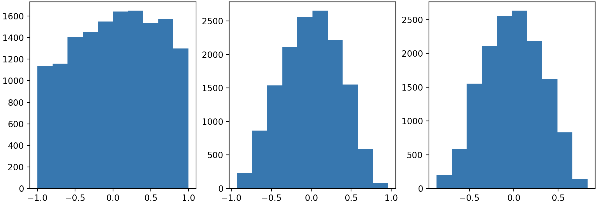

For better informativeness we’ll look at probabilities the price goes up n seconds after observing orderbook imbalance between quantiles of orderbook imbalance distribution for on figure 2, with 3 (left figure) and 5 (right figure) cumulative volume levels.

Fig. 2. Empirical probability of positive price change against quantile of orderbook imbalance on different time horizons at 3rd, 5th cumulative levels
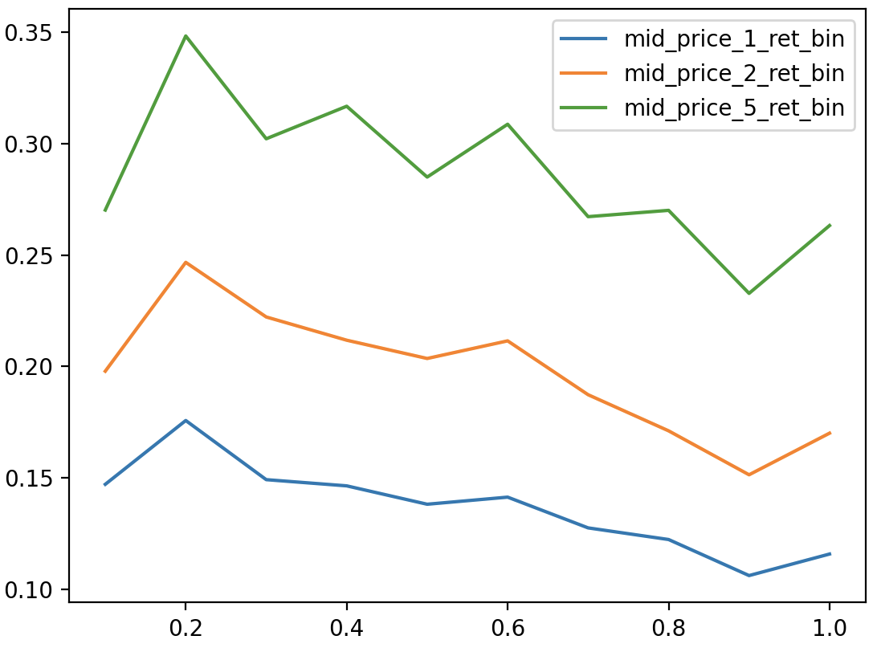 | 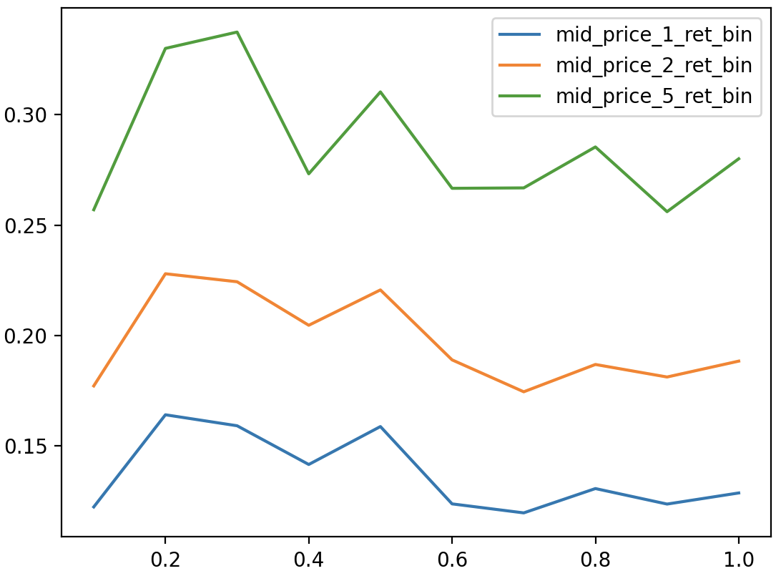

As expected, 5-second periods in general show higher probability of up move both for 3 and 5 level data. What is unusual for general numbers: both at 5 and 3 cumulative levels, the higher the orderbook imbalance, the lower the probability to observe price move up. Probability of positive price move peaks around 35-30% at 3 and 5 cumulative OB negative imbalance (-0.2:-0.3] quantile.
The picture is different for probabilities of negative price moves on 5-second resolutions, where probability of down moves peaks at middle OB imbalances(-0.5:-0.6] quantiles.

Fig. 3. Empirical probability of negative price change against quantile of orderbook imbalance on different time horizons at 3rd, 5th cumulative levels
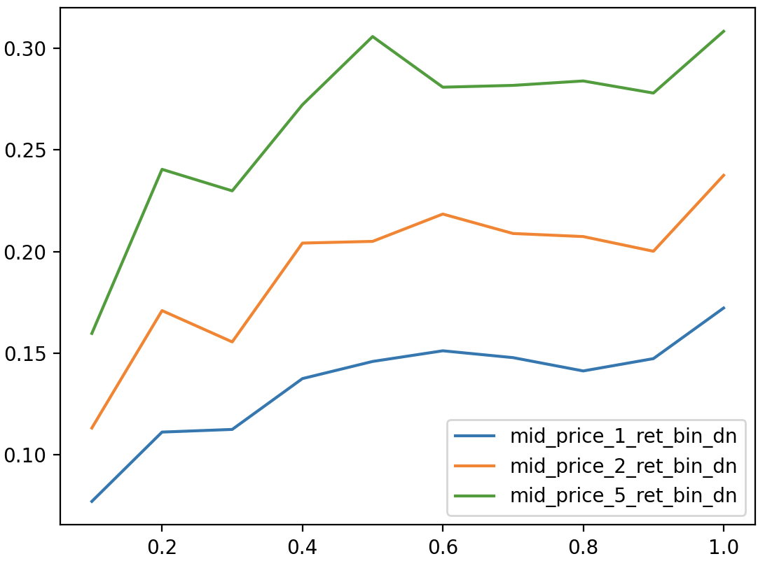 | 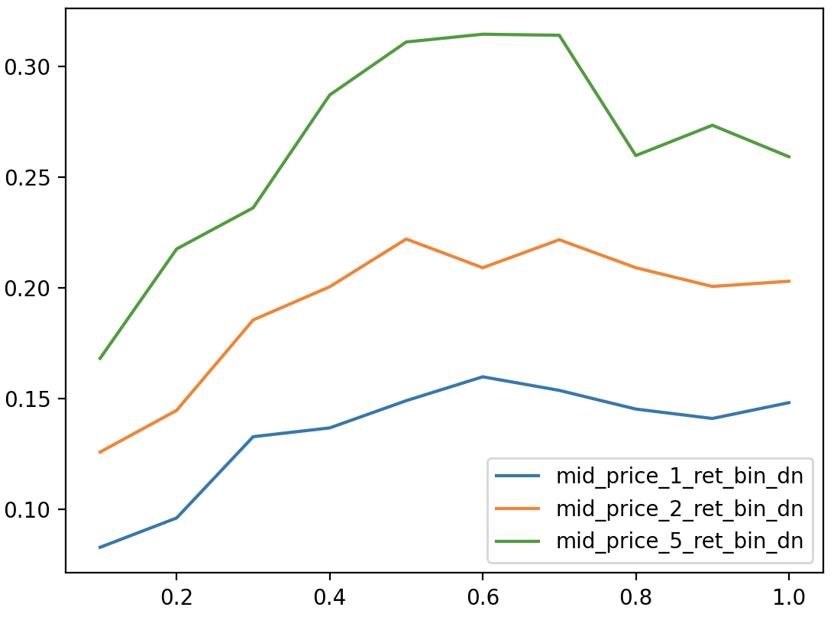

The bottom line is: lower OBI -> lower bid concentration in orderbook – higher probability of positive price moves. The signal only strengthens with time and it is asymmetrical. P(up| low OBI) and P(down | mid-high OBI) are highest.

Given the regimes we have, let’s first make a logit model to estimate odds of observing price increase.
For general observations we fitted a model with an intercept and orderbook imbalance. Here are the results for the models. Given models truthfully highlight that a higher OBI negatively impacts log odds of positive price change (A 1-unit increase in OBI 5 (3) level is associated with 14.2% (23.5%) lower odds of an upward price move), which means 3.12 (5.46) percentage point decrease in the probability of an upward price move.

Table 3: Coefficients of logit model for 3rd and 5th level orderbook imbalance.
 | Model 1 |  |  | Model 2
 | const | OBI_5lvl |  | const | OBI_3lvl
log-odds | -0.915 | -0.153 |  | -0.916 | -0.268
stderr | 0.018 | 0.056 |  | 0.018 | 0.051
pvals | 0 | 0.007 |  | 0 | 0

However, the fit is very poor: despite the fact that the fit of both models is bad: Pseudo R squared is less than 0.01 and Log-Likelihood -8618.7 is slightly better than null model (-8622.4). Adding features (both orderbook Imbalances and spread at first level) does not help much: Pseudo R squared is around 0.02 and Log-Likelihood -8427.5.

Table 3: Coefficients of logit model for 3rd and 5th level orderbook imbalance.
 | log-odds | stderr | pvals
const | -1.354 | 0.032 | 0.000
OBI_3lvl | -0.575 | 0.086 | 0.000
OBI_5lvl | 0.339 | 0.095 | 0.000
spread_1lvl_bps | 0.530 | 0.031 | 0.000

Despite bad fit, we can see a decent confusion matrix with threshold score of 0.31:
 | precision | recall | f1-score | support
0 | 0.75 | 0.84 | 0.77 | 10242
1 | 0.4 | 0.34 | 0.37 | 4113
Accuracy |  |  | 0.67 | 14355
Macro avg | 0.58 | 0.57 | 0.57 | 14355
Weighted avg | 0.65 | 0.67 | 0.66 | 14355

AUC score is 0.62, which is a good result for such a poor fit.

Now let’s look at models in various selected regimes. First, let’s describe how the regimes are selected:

Name | Characteristic | Explanation
good_quality | Mid to high price move prob + normal-low churn + normal-low spreads | Tradable stable market

Let’s now try to model two separate regimes and compare the results for “good” and “bad” quality data.

 | Model 1 |  |  |  | Model 2
 | log-odds | stderr | pvals |  | log-odds | stderr | pvals
const | -1.465 | 0.036 | 0.000 |  | -0.565 | 0.097 | 0.000
OBI_3lvl | -0.704 | 0.095 | 0.000 |  | -0.091 | 0.206 | 0.661
OBI_5lvl | 0.431 | 0.105 | 0.000 |  | -0.088 | 0.226 | 0.697
spread_1lvl_bps | 0.637 | 0.039 | 0.000 |  | 0.031 | 0.066 | 0.635
Pseudo R-squ | 0.0233 |  |  |  | 0.000
Log-Likelihood | -6843.6 |  |  |  | -1543.2
LL-Null | -7006.8 |  |  |  | -1544.2
LLR p-value | 0 |  |  |  | 0.5652

Orderbook imbalances for level 3 and level 5 are not significant for “good” quality data regime. The model itself does not explain returns in that regime, containing only 2340 observations. The model 1 for “bad” quality data shows that by default, log-odds of upward move = -1.465 → baseline probability = 18.7%. A 1-unit increase in OBI 3rd lvl is associated with 50.5% lower odds of upward move, 1-unit increase in OBI 5th lvl is associated with 53.9% higher odds of upward move, while a 1 bps increase in spread is associated with 89.1% higher odds of upward move

Deeper order book imbalance (OBI_5lvl) is positively associated with upward price moves (OR = 1.54, p < 0.001), while shallow imbalance (OBI_3lvl) shows a negative relationship (OR = 0.50, p < 0.001), suggesting that only sustained buying pressure beyond the top 3 levels is predictive. Wider spreads also increase the odds of upward moves (OR = 1.89 per bps, p < 0.001), possibly reflecting inventory imbalances or informed trading

Deeper modelling and comparison

Correlation analysis
We are observing several variables that could impact returns. The endogenous variable is binary, depicting whether there was an increase in price 1,2, and 5 seconds after the observation. OBI means orderbook imbalance at a denoted level, churn means cumulative change at a denoted level.

 |  | mid_price_5_ret_bin | mid_price_2_ret_bin | mid_price_1_ret_bin
Total | OBI_3lvl | -0.044 | -0.054 | -0.049
 | OBI_5lvl | -0.023 | -0.021 | -0.021
 | spread_1lvl_bps | 0.145 | 0.132 | 0.124
 | ΔV1_churn | 0.083 | 0.091 | 0.106
 | ΔV3_churn | 0.100 | 0.112 | 0.125
Good quality | OBI_3lvl | -0.027 | -0.030 | -0.027
 | OBI_5lvl | -0.022 | -0.001 | 0.003
 | spread_1lvl_bps | 0.003 | 0.009 | -0.003
 | ΔV1_churn | -0.021 | 0.007 | 0.029
 | ΔV3_churn | 0.000 | 0.031 | 0.056
Bad quality | OBI_3lvl | -0.051 | -0.062 | -0.054
 | OBI_5lvl | -0.022 | -0.025 | -0.026
 | spread_1lvl_bps | 0.155 | 0.151 | 0.163
 | ΔV1_churn | 0.116 | 0.116 | 0.123
 | ΔV3_churn | 0.138 | 0.144 | 0.146

As is visible, good quality label actually labeled the regime that is less impacted by the factors considered in this research. The correlation of 3d level orderbook imbalance remains negative in each regime, but the correlation goes closer to 0 in “good quality” regime. It also looks like the churn (or cumulative change in the volumes) is more correlated and should be research too. Also, as is visible, orderbook imbalances are strongly correlated, and including them together can improve the model, but at cost of multicollinearity. On the other hand, churns at different levels are not correlated to each other and have higher correlation with endogenous variable.

Fig. 4. Correlations between churns and orderbook imbalances
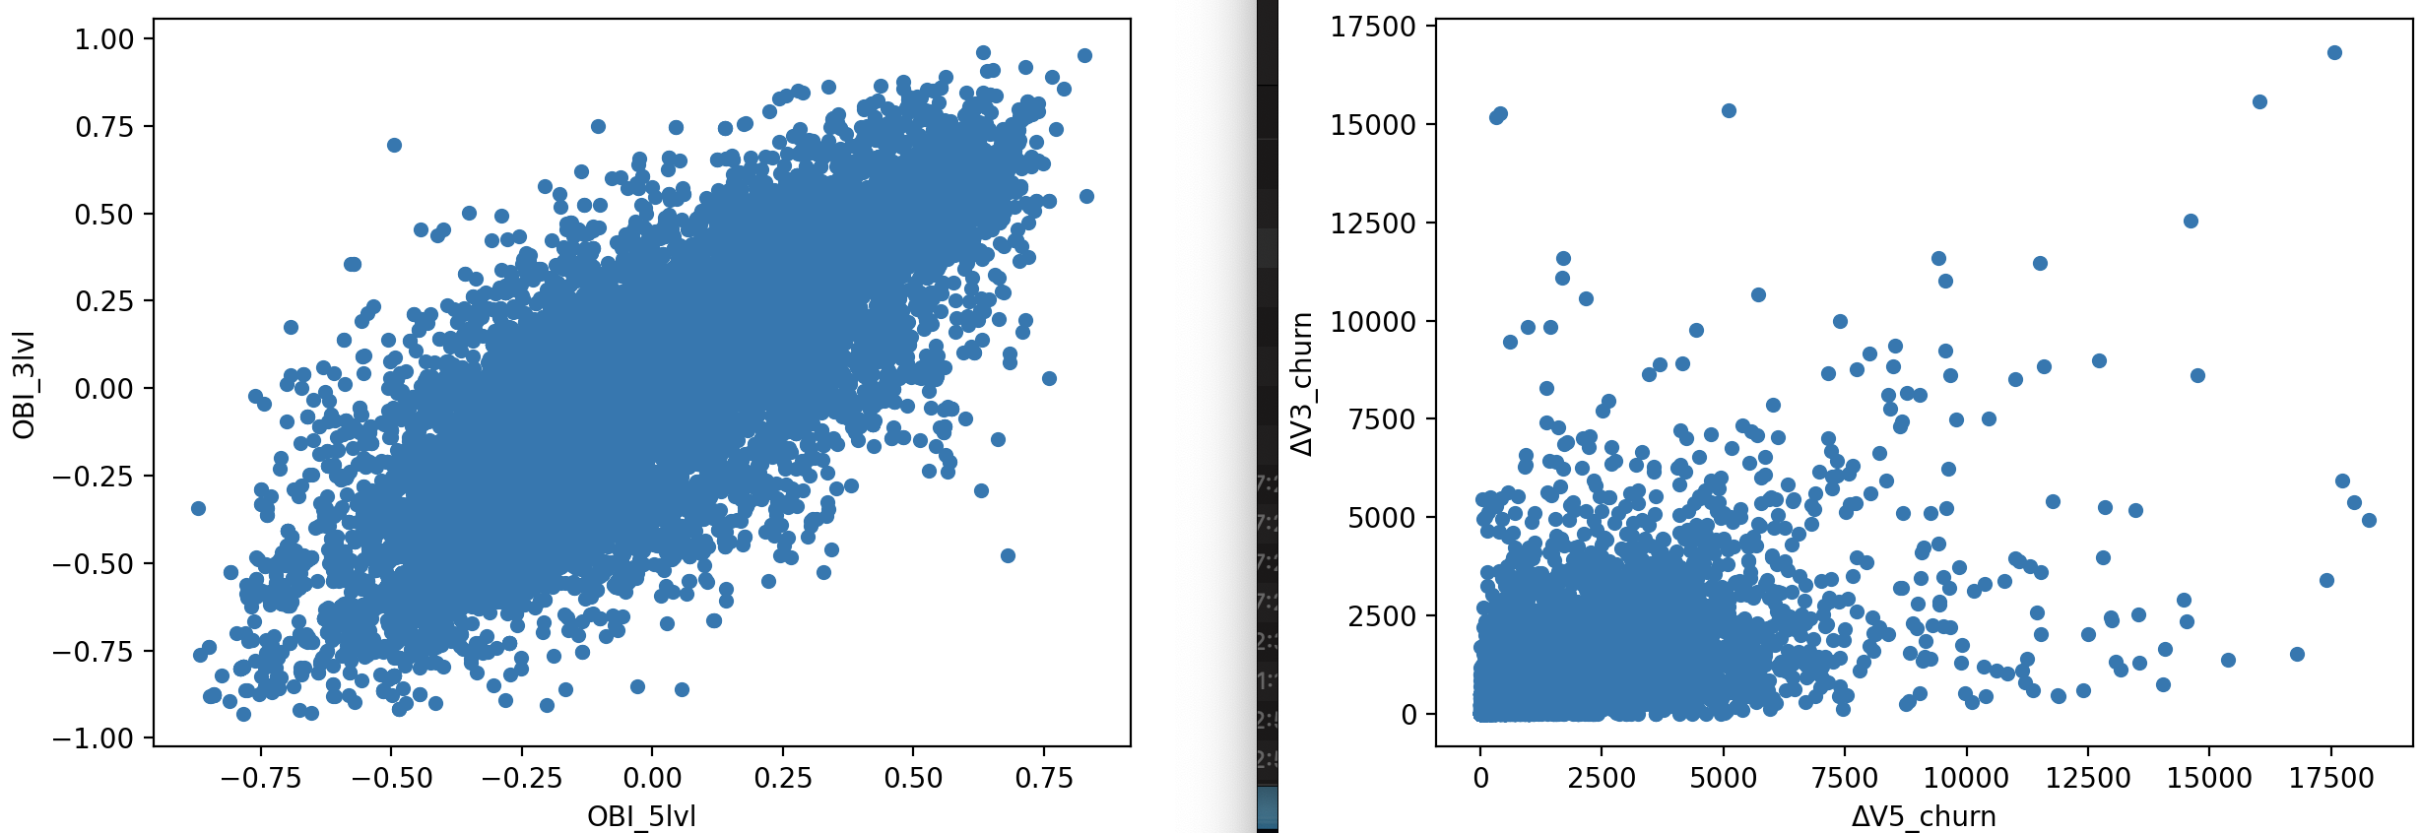

To evaluate impact of chosen variables with selected regimes, we’ll specify a range of logit models:

full_5s_OBI
$mid_price_5_ret_bin = β₀ + β₁·OBI_3lvl + β₂·OBI_5lvl + β₃·spread_1lvl_bps + ε$
full_5s_churn
$$mid_price_2_ret_bin = β₀ + β₁·ΔV3_churn + β₂·ΔV5_churn + β₃·spread_1lvl_bps + ε$$
full_1s_OBI
$$mid_price_1_ret_bin = β₀ + β₁·OBI_3lvl + β₂·OBI_5lvl + β₃·spread_1lvl_bps + ε$$

full_5s_pooled_churn
mid_price_5_ret_bin = β₀ + β₁·ΔV3_churn + β₂·ΔV5_churn + β₃·spread_1lvl_bps
+ β₄·good_quality + β₅·(ΔV3_churn × good_quality)
+ β₆·(ΔV5_churn × good_quality) + β₇·(spread_1lvl_bps × good_quality) + ε

full_5s_pooled_churn+
mid_price_5_ret_bin = β₀ + β₁·(ΔV3_churn × good_quality) + β₂·L1_ΔV3_churn
+ β₃·(ΔV3_churn² × good_quality) + β₄·L1_ΔV5_churn + β₅·spread_1lvl_bps + ε

full_5s_pooled_OBI
mid_price_5_ret_bin = β₀ + β₁·OBI_3lvl + β₂·OBI_5lvl + β₃·spread_1lvl_bps
+ β₄·good_quality + β₅·(OBI_3lvl × good_quality)
+ β₆·(OBI_5lvl × good_quality) + β₇·(spread_1lvl_bps × good_quality)
+ β₈·(OBI_3lvl × spread_1lvl_bps) + ε

full_5s_lagged_both
mid_price_5_ret_bin = β₀ + β₁·OBI_3lvl + β₂·OBI_5lvl + β₃·L1_OBI_3lvl + β₄·L1_OBI_5lvl
+ β₅·ΔV3_churn + β₆·ΔV5_churn
+ β₇·L1_ΔV3_churn + β₈·L1_ΔV5_churn + β₉·spread_1lvl_bps + ε

Models full_5s_pooled_churn+ and full_5s_lagged_both appeared to be the strongest model in terms of fit due to inclusion of nonlinearity and lagged values.

Model evaluations:
 | AIC | BIC | R2 | llnull | llf
full_5s_OBI | 16914 | 16944 | 0.020 | -8622 | -8453
full_5s_churn | 16851 | 16881 | 0.023 | -8622 | -8421
full_1s | 11267 | 11297 | 0.022 | -5756 | -5630
full_5s_pooled_churn | 16749 | 16810 | 0.030 | -8622 | -8367
full_5s_pooled_churn+ | 16674 | 16742 | 0.034 | -8622 | -8328
full_5s_pooled_OBI | 16826 | 16895 | 0.025 | -8622 | -8404
full_5s_lagged_both | 16711 | 16787 | 0.032 | -8622 | -8346

The pool of models dictates significant intercept, that baseline probability of observing increase in price is around 9-20%. General overview of coefficients proves negative impact of 3d level orderbook imbalance across models: A 1-unit increase in OBI_3lvl is associated with lower chances (odds) of a positive 1s/5s price move by 0.42-0.55. However, effect of 5th level orderbook imbalance is not that stable across models and reverse: an increase of deeper orderbook level imbalance leads to higher chances (odds) of price increase by 1.43-1.8 (43-80% increase in chances). Wider spreads consistently increase odds by 59-90% (OR = 1.59-1.90), possibly reflecting adverse selection. Good quality regime itself, however, increases odds 1.75 – 2.72 times.

Thresholds and confusion matrices.
 | 11 | 00 | 10 | 01 | ROC_AUC | opt_threshold
full_5s_OBI | 3227 | 3912 | 896 | 6363 | 0.62 | 0.25
full_5s_churn | 3301 | 4332 | 822 | 5942 | 0.64 | 0.24
full_1s | 962 | 8760 | 1013 | 3663 | 0.62 | 0.14
full_5s_pooled_churn | 3344 | 4234 | 779 | 6040 | 0.64 | 0.22
full_5s_pooled_churn+ | 3321 | 4340 | 802 | 5933 | 0.65 | 0.22
full_5s_pooled_OBI | 3348 | 3609 | 775 | 6666 | 0.62 | 0.24
full_5s_lagged_both | 3055 | 5155 | 1068 | 5118 | 0.65 | 0.25

We are capable of achieving AUC of 0.62-0.65 with our modelling.
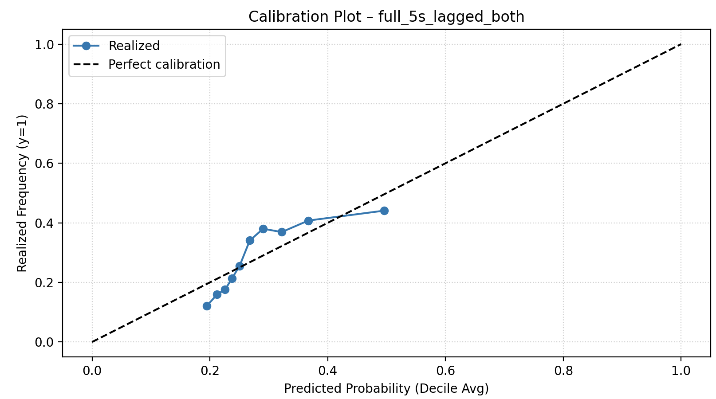

Table 1: Percent of up price returns vs OB cumulative 5th lvl orderbook imbalance

 | mid_price_1_ret_bin | mid_price_2_ret_bin | mid_price_5_ret_bin
10% | 12% | 18% | 26%
20% | 16% | 23% | 33%
30% | 16% | 22% | 34%
40% | 14% | 20% | 27%
50% | 16% | 22% | 31%
60% | 12% | 19% | 27%
70% | 12% | 17% | 27%
80% | 13% | 19% | 29%
90% | 12% | 18% | 26%
100% | 13% | 19% | 28%

Table 2: Percent of up price returns vs OB cumulative 3^{d} lvl orderbook imbalance

 | mid_price_1_ret_bin | mid_price_2_ret_bin | mid_price_5_ret_bin
10% | 15% | 20% | 27%
20% | 18% | 25% | 35%
30% | 15% | 22% | 30%
40% | 15% | 21% | 32%
50% | 14% | 20% | 28%
60% | 14% | 21% | 31%
70% | 13% | 19% | 27%
80% | 12% | 17% | 27%
90% | 11% | 15% | 23%
100% | 12% | 17% | 26%

Table 3: Percent of down price returns vs OB cumulative 3^{d} lvl orderbook imbalance

 | mid_price_1_ret_bin_dn | mid_price_2_ret_bin_dn | mid_price_5_ret_bin_dn
10% | 8% | 11% | 16%
20% | 11% | 17% | 24%
30% | 11% | 16% | 23%
40% | 14% | 20% | 27%
50% | 15% | 21% | 31%
60% | 15% | 22% | 28%
70% | 15% | 21% | 28%
80% | 14% | 21% | 28%
90% | 15% | 20% | 28%
100% | 17% | 24% | 31%

Table 4: Percent of down price returns vs OB cumulative 5th lvl orderbook imbalance

 | mid_price_1_ret_bin_dn | mid_price_2_ret_bin_dn | mid_price_5_ret_bin_dn
10% | 8% | 13% | 17%
20% | 10% | 14% | 22%
30% | 13% | 19% | 24%
40% | 14% | 20% | 29%
50% | 15% | 22% | 31%
60% | 16% | 21% | 31%
70% | 15% | 22% | 31%
80% | 15% | 21% | 26%
90% | 14% | 20% | 27%
100% | 15% | 20% | 26%

Variable | Intercept | I(ΔV3_churn ** 2) | I(ΔV3_churn ** 2):good_quality | L1_OBI_3lvl | L1_OBI_5lvl | L1_ΔV3_churn | L1_ΔV5_churn | OBI_3lvl | OBI_3lvl:good_quality | OBI_3lvl:spread_1lvl_bps | OBI_5lvl | OBI_5lvl:good_quality | good_quality | spread_1lvl_bps | spread_1lvl_bps:good_quality | ΔV3_churn | ΔV3_churn:good_quality | ΔV5_churn | ΔV5_churn:good_quality
Coefficient_full_1s | -2.290 |  |  |  |  |  |  | -0.875 |  |  | 0.587 |  |  | 0.510
Coefficient_full_5s_OBI | -1.349 |  |  |  |  |  |  | -0.592 |  |  | 0.361 |  |  | 0.522
Coefficient_full_5s_churn | -1.432 |  |  |  |  |  |  |  |  |  |  |  |  | 0.465 |  | 0.000 |  | 0.000
Coefficient_full_5s_lagged_both | -1.521 |  |  | 0.299 | 0.354 | 0.000 | 0.000 | -0.777 |  |  | -0.117 |  |  | 0.490 |  | 0.000 |  | 0.000
Coefficient_full_5s_pooled_OBI | -1.474 |  |  |  |  |  |  | -0.917 | 0.386 | 0.289 | 0.437 | -0.455 | 0.927 | 0.640 | -0.619
Coefficient_full_5s_pooled_churn | -1.537 |  |  |  |  |  |  |  |  |  |  |  | 1.000 | 0.479 | -0.460 | 0.000 | 0.001 | 0.000 | 0.000
Coefficient_full_5s_pooled_churn+ | -1.583 | 0.000 | 0.000 |  |  | 0.000 | 0.000 |  |  |  |  |  | 0.560 | 0.315 |  | 0.000 | -0.001
Std.Err._full_1s | 0.040 |  |  |  |  |  |  | 0.113 |  |  | 0.124 |  |  | 0.034
Std.Err._full_5s_OBI | 0.032 |  |  |  |  |  |  | 0.086 |  |  | 0.095 |  |  | 0.030
Std.Err._full_5s_churn | 0.033 |  |  |  |  |  |  |  |  |  |  |  |  | 0.030 |  | 0.000 |  | 0.000
Std.Err._full_5s_lagged_both | 0.035 |  |  | 0.118 | 0.154 | 0.000 | 0.000 | 0.118 |  |  | 0.154 |  |  | 0.031 |  | 0.000 |  | 0.000
Std.Err._full_5s_pooled_OBI | 0.036 |  |  |  |  |  |  | 0.116 | 0.233 | 0.095 | 0.105 | 0.248 | 0.103 | 0.038 | 0.076
Std.Err._full_5s_pooled_churn | 0.036 |  |  |  |  |  |  |  |  |  |  |  | 0.106 | 0.039 | 0.076 | 0.000 | 0.001 | 0.000 | 0.000
Std.Err._full_5s_pooled_churn+ | 0.036 | 0.000 | 0.000 |  |  | 0.000 | 0.000 |  |  |  |  |  | 0.063 | 0.033 |  | 0.000 | 0.003
P-value_full_1s | 0.000 |  |  |  |  |  |  | 0.000 |  |  | 0.000 |  |  | 0.000
P-value_full_5s_OBI | 0.000 |  |  |  |  |  |  | 0.000 |  |  | 0.000 |  |  | 0.000
P-value_full_5s_churn | 0.000 |  |  |  |  |  |  |  |  |  |  |  |  | 0.000 |  | 0.000 |  | 0.000
P-value_full_5s_lagged_both | 0.000 |  |  | 0.011 | 0.022 | 0.000 | 0.006 | 0.000 |  |  | 0.447 |  |  | 0.000 |  | 0.000 |  | 0.009
P-value_full_5s_pooled_OBI | 0.000 |  |  |  |  |  |  | 0.000 | 0.099 | 0.002 | 0.000 | 0.066 | 0.000 | 0.000 | 0.000
P-value_full_5s_pooled_churn | 0.000 |  |  |  |  |  |  |  |  |  |  |  | 0.000 | 0.000 | 0.000 | 0.000 | 0.528 | 0.000 | 0.012
P-value_full_5s_pooled_churn+ | 0.000 | 0.000 | 0.882 |  |  | 0.002 | 0.003 |  |  |  |  |  | 0.000 | 0.000 |  | 0.000 | 0.794

